B.M.S COLLEGE OF ENGINEERING



SYSTEM SOFTWARE PROJECT REPORT ON
TEXT EDITOR

DEPARTMENT OF COMPUTER SCIENCE AND ENGINEERING

SUBMITTED BY:
SASWAT RAJ PANDEY(1BM11CS097)
SAURAV RIMAL(1BM11CS102)
V Semester

CERTIFICATE

This is to certify that Mr. Saswat Raj Pandey bearing USN1BM11CS097 has satisfactorily completed the project on creating a text editor as prescribed by B.M.S College of Engineering(Autonomous University under VTU) in the subject ‘System Software’ for semester 5 in the year 2013-2014.

Marks obtained: ………..
Maximum marks: …………
Date: ………………………….

Signature of evaluator: Signature of student:

CERTIFICATE

This is to certify that Mr. Saurav Rimal bearing USN1BM11CS102 has satisfactorily completed theproject on creating a text editor as prescribed by B.M.S College of Engineering(Autonomous University under VTU) in the subject ‘System Software’ for semester 5 in the year 2013-2014.

Marks obtained: ………..
Maximum marks: …………
Date: ………………………….

Signature of evaluator: Signature of student:

INDEX

1. Certificate

- Abstract

- Acknowledgement

4. Chapter 1: introduction

5. Chapter 2: literature survey

6. Software and Hardware requirements

7. Design and implementation

8. Conclusion and future scope

9. References

Abstract

The particular text editor which has been designed during the course of this project aims at providing a basic text editor window. It has simple text editing features like copy, cut, paste, to upper, to name a few.
It enables forward, backward, upward and downward traversing of the cursor on the text editor screen. The project has a number of modules to support the various editing features. Saving created files and opening existing files is also possible. Various shortcuts have been provided for a more user-friendly environment. Written in the C language, the text editor can be compiled and executed using Turbo C. As per the requirements of the user, it can easily be customized and developed.
This text editor has been developed with a layered approach. The topmost Main Window is not involved in text editing. It simply provides an Editor-User interface. It includes the menu and status bars. The next is the Text View which is the child of the aforementioned. This is the visual component of the editor whose primary focus is on displaying and editing text, besides which it also displays scrollbars, processes keyboard input. The third component is the Text Document which is used to manipulate a text file once it has been loaded into the memory. The bottommost layer is technically not a part of the text editor but plays a vital role. It stored the text to be edited. The level above will directly interface with this. Reading and writing is performed when a document is loaded or saved.
This project is capable of handling files of a comparatively small size. A buffer is used to get the contents of an entire file. Thus, memory management problems arise while handling larger files due to the aforementioned limitation.
ACKNOWLEDGEMENT

We would, firstly, like to thank our System Software lecturer, under whose guidance and support this project was successful. The supervision and support he gave us truly helped us in the progression and smoothness of this project. The co-operation is much indeed appreciated.

Secondly, we are grateful to our department faculty which has provided us with the facilities which enabled us to work on the project hassle-free.

We would also like to thank a few of our seniors, who took time out to tell us how to go about doing this project.

Last but not the least we wish to avail ourselves of this opportunity, express a sense of gratitude to our beloved parents for their support, encouragement, strength and for everything.

CHAPTER 1 : INTRODUCTION

TED-short for Text Editor, is a is a full screen text editor designed for the operating system. It features an interactive and user-friendly interface, and is equipped with many commonly used text editing features.

1.1 PURPOSE
The main purposes this editor intends to fulfill are as follows:

Provide users a convenient way to create, open, modify and save their text files.
Provide an easy-to-learn and use text-editing software.
Provide programmers with a platform for creating and modifying source files of various programming languages.

1.2 SCOPE
The scope of this software is limited to the manipulation of text documents that contain pure ASCII text. Due to this reason, it cannot work with documents created by word-processing software.
Furthermore, TED is designed to run only under the WINDOWS operating system environment.

CHAPTER 2 : LITERATURE

TED is intended as a general-purpose text-editing program for use by any user wishing to view or edit pure ASCII text files. Additionally programmers wishing to write their source programs, can also use TED for their editing needs.

TED has been designed mainly keeping in mind the needs of users. For this reason, the design philosophy of TED has been to keep the interface very simple and straightforward to learn and use.

A considerable effort has been made during the overall design of TED to keep the learning curve of the software as low as possible, to enable new users to progressively adapt to the environment, before using advanced editing systems.

CHAPTER 3: SOFTWARE AND HARDWARE REQUIREMENTS

3A : HARDWARE REQUIREMENTS

The hardware requirements required by TED for its proper functioning are very minimal. These basic requirements are listed below.

A minimum of 486DX processor or equivalent.

4 MB of free user memory.

10 MB of free hard disk space.

An ASCII compatible keyboard, an optionally, a PS/2 or serial interface mouse .

A hardware terminal interface.

3A1 : HARDWARE LIMITATIONS

The hardware limitations that affect the functionality of TED are listed below.

1. The TED programming logic requires an ASCII standard compatible keyboard interface to accept user input. Any other standard has not been implemented in TED.

3B :SOFTWARE REQUIREMENTS

The overall software interface required by TED consists of the following components:
1. A functional Windows operating system.
2. The Turbo C++ and GCC compiler environment.
3. The C++ Standard Template Library - The C++ STL templates are used for management of the data structures in TED, and hence are essential to the proper execution of TED. These templates form the basic structure of text buffer databases in TED.

3C: PERFORMANCE REQUIREMENTS

The performance requirements for TED can be stipulated as follows:
1. Ability to manage large files – TED can comfortably work with files with sizes of 20 MB or less.
2. Robustness – TED handles most of the possible error conditions while that can occur while processing, like the ones listed below.
a. Corrupted files and files with non-ASCII printable content - When loading such files, TED reports an error message and aborts the file loading process.
b. Memory allocation errors – TED is equipped to handle memory allocation failures that may occur due to insufficient memory space.
c. File system errors – TED also handles abnormal situations occurring due to file operation errors due to errors in the file system.

3D : DESIGN CONSTRAINTS

The following constraints apply to TED operations due to its TED.
1. TED cannot work with extremely large files (Size greater than 50 MB).
2. TED cannot process non-ASCII information.
3. Due to its interactive nature, TED cannot operate in batch processing environment.
4. TED cannot open files with extremely long lines with 1024 characters or more.

CHAPTER 4 : DESIGN AND IMPLEMENTATION
4A : DESIGN
The following diagram illustrates the basic architectural design of TED

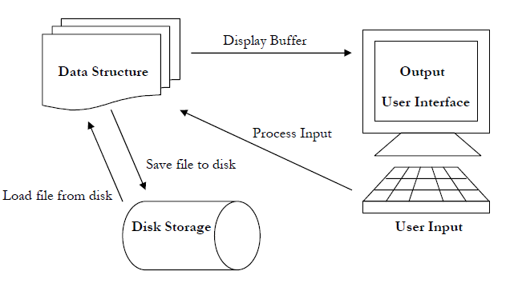
BASIC ARCHITECTURAL DESIGN OF TED
The buffer used to store text read in from the user input, and/or from loading files from the disk is a data structure, designed to hold the text in units of strings, each unit containing one line of text. This idea is illustrated in the diagram below.

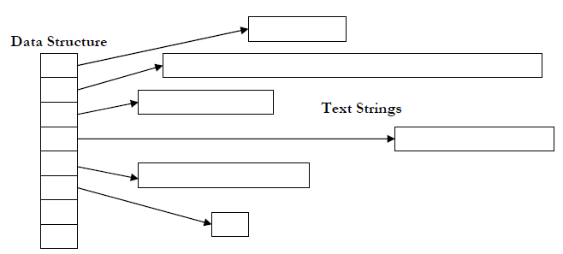
THE TEXT BUFFER DATA STRUCTURE

The diagrams show the basic design of TED. The various components of the diagrams, and the details of operation of the editor are explained in the subsections below.

4A 1 : INPUT
TED accepts inputs from the user from the keyboard, and optionally from the mouse. The input to TED can be any one of the following:
1. An ASCII-printable character – In this case, TED accepts this character as text input, and inserts it into the current buffer appropriately.
2. A Navigation command – The user can issue navigation commands using any of the navigation keys on the keyboard, like the ARROW keys, HOME, END etc. When such a request is recognized, TED appropriately the text cursor to fulfill the request.

3. A Control key sequence – The user can also issue specialized commands to TED, for performing specific operations, by using a combination of the CTRL (META), ALT and FUNCTION keys. When such a key sequence, known as a hotkey sequence is recognized, TED performs the desired operation.

The input operations of TED are interfaced with the hardware of the system by the ncurses library. The library has a large database of functions for performing input operations. These functions can be used to obtain data from the user, in the form of text input, numeric values etc. By using only these functions for performing I/O, the design of TED is ensured to generic across various terminal types and underlying hardware.

Disk Input
In addition to these methods input, TED performs input operations from the disk storage, while reading files and loading into the text buffers. In this regard, the following facts are relevant.
1. TED can open files stored at any location in any of the currently mounted file systems.
2. TED cannot open files for which the user does not have read permissions. In such a situation, TED reports an error message to the user.
3. TED can open files on the disk that are of the DOS text format.
4. TED can have multiple files open at any time. Each file is associated with its own buffer. TED allows users to perform text block operations between the open buffers.

4A 2 : PROCESSING

The basic approach to input processing in TED is fundamental to conditional switching and program execution according to the precepts of structural programming. When TED is first loaded into memory as a process by the shell, it execute some initialization code, and enters an input processing loop structure, where it waits for input from the user, and processes it appropriately, using a conditional switching logic.
The basic algorithm for accomplishing this is illustrated below. This sequence of instructions is endlessly and repeatedly executed till the user explicitly terminates the loop by issuing an exit command.
ALGORITHM
While (not terminated) {
Get input from the user
Determine the type of the input character {
If it is an ASCII printable character, insert into the current buffer.
If it is a navigation command, appropriately position the cursor.
If it is a menu command sequence, execute the menu operation requested.
If it is a control key sequence, execute the requested command.
If it is a mouse event, process the request.
If it is none of the above cases, ignore it.
If it is an exit command, execute pre-termination code, and exit the loop.
} } THE MAIN INPUT-PROCESSING LOOP

4A 3 : OUTPUT

The output from TED, occurring as a response to user requests, is directed towards two destinations. These are –
1. The User’s terminal – TED outputs messages, status information, Error messages, and other diagnostic messages to the user via his/her terminal interface.
Windows are demarcated areas of the user’s terminal. Additionally, the window output can be formatted as desired by the application programmer. TED uses ncurses windows to display its text buffers to the user.

2. The disk storage – TED also outputs data to the disk storage, normally the hard disk, as a response to save requests by the user. When such a request occurs, TED writes the contents of the text buffer to disk. TED can save the contents of its buffers to a file at any location in any of the currently mounted file systems. This gives the user a large amount of flexibility in saving the file to any desired location. In case there already exists a file with the same pathname and filename as the specified one, TED prompts the user whether the existing file should be replaced. If the user does not have permissions to write to the existing file or directory, TED prints an appropriate error message.

4A 4: USER INTERFACE
The user interface offered by TED is a very simple and easy to use one. The learning curve for becoming familiar with the TED User Interface is negligible. This ease of use is made possible by using the following user interfacing methods –
Dialog Boxes – TED incorporates the concept of dialog boxes, found in many interactive software systems. Dialog boxes provide an easy–to-understand and efficient method of communication between the user and the software. The following types of Dialog box systems are used in TED.
1. Message Box – This type of dialog box is used to present a prompt with a title to the user, and give an option to answer to the prompt in the affirmative or the negative, by selecting one of the available choices.
2. Input Box – The Input Box dialog system is used for accepting input from the user. The input data can be of string, integer or other data-type formats. A dialog box is presented to the user, with a field for entering the requested information. Also, a choice of options is provided so that the operation can be canceled at any time.
3. Text Box – The Text Box dialog box is a simple one, and it presents a simple text message to the user. It does not have the facility to ask any questions or return any information to the program. It is mainly used to display relatively large amounts of text information to the user.

Menu interface systems - TED uses pull-down menu systems to present the user with a set of selectable choices. Additionally, for experienced users, TED also offers keyboard shortcuts to most of the TED menu options, to enable them to work faster. The Menu systems implemented in TED are detailed below.

File Menu – The file menu contains options for performing various file operations.
1. New – Creates a new text document.
2. Open – Creates a new text document and loads it with a file from disk. The user is prompted to enter desired file to open.

3. Save – Saves the currently active document.
4. Save as – Saves the currently active document with a different name.
5. Change Directory – Used to change the directory address.
6. Exit – Exits TED. The user is prompted to save any unsaved files to disk.

Edit menu – The Edit menu contains options for performing text block operations.

1. Cut Line – Cuts out the selected block of text, starting at the begin mark position, and terminating at the current cursor position, and puts it into the clipboard.
2. Copy Line– Copies the selected block of text, starting at the begin mark position, and terminating at the current cursor position, and puts it into the clipboard.
3. Paste Line– Pastes the contents of the clipboard into the currently active document at the current cursor position.
4. Insert date –Inserts the present date
Help Menu – The help menu contains options to display TED user commands and information about TED.

1. Help – Displays a text box enumerating the commands in TED.
2. About – Displays a text box with information about TED.

CASE MENU –The case menu contains options to change the case of user commands.
1.To upper – This function converts all the characters
to uppercase.
2.To Lower – This function converts all the characters to lower case.
3.Toggle Case –This function converts upper case characters to lower case and vice-versa.
4B: IMPLEMENTATION

The important member functions of this class are listed below:
Display_screen(): this function is used to display the menu functions like: help, edit and file. This function is used to display the status bar and menu bar.
Normal_key(): this is used to check what kind of key is entered whether it’s a character, number or a special character.
Display line(): this function Is used to display the current line. (ie. Line of current node.)
Display_afterline(): this function is used to display all lines after the current line.
Scroll_down(): this function is used to scroll down the editor window.
Scroll up(): this function is used to scroll up the editor window.
Display_status(): this is used to display the status bar which contains the name of the file.
Get_menu_choice():this function is used to get the menu.
Do_file(): this is used for 1: create file 2: save as 3: open 4:save 5: change directory.
Free memory(): this is used to free the memory allocated to the linked list.
Check_save(): this asks the user whether to save the file or not.
Create_new(): used to create a new file.
Open_file(): this is used to open a file that is entered by the user.
Draw_dialogue(): draws a dialogue on the screen saving the previous screen.
Cut_line(): this function is used to cut/remove the current line.
Copy_line(): this function is used to copy the current line.
Paste_line(): this function is used to paste the line which was copied.
Help_window(): this displays the help window on the editor.
CODE

#include"stdio.h"
#include"conio.h"
#include"dos.h"
#include"dir.h"
#include"string.h"
#include"ctype.h"

char far *Vid_base=0xb8000000; /*VDU base memory address*/

int i,j;
char *menulist[]={"*File","*Edit","*Search","*Case","*Help"};
int xpos=1,ypos=1,ins=1,Exit_Forge=1,choice,save=1,tx,ty;
char ch,filename[15]="UNTITLED.TXT",*dbuff,cpline[78],cplen,fstring[40],ttime[15];
union REGS in; /*for interrupt functions*/

struct data /*the struct definition for the linked list*/
{
char text[78];
struct data *prev,*next;
int length;
};

typedef struct data LINE;
LINE *Cur_line,*start;
char *filemenu[]={"^New","^Open...","^Save","Save ^As...","^Change Dir","^Dos Shell","^Exit"},
*editmenu[]={"Cu^t Line","^Copy Line","^Paste Line","Insert ^Date"},*srchmenu[]={"^Find...","Find ^Next"},
*casemenu[]={"To ^Upper","To ^Lower","^Toggle Case"};
*helpmenu[]={"^Contents","^About"};
struct time t;
void insert_date();

void main(int argc,char *argv[])
{
clrscr();
window(2,3,79,24); /*set the window area*/
Cur_line=(LINE*)malloc(sizeof(LINE));
start=Cur_line;
Cur_line->next=NULL; /*initialization of the first node*/
Cur_line->prev=NULL; Cur_line->length=0;

Display_screen(); /*display list of menus*/
Display_status();
gotoxy(1,1);
setkeyboard();
while(Exit_Forge) /* the master loop*/
{
ch=getch();

if(ch==0)
Special_key(); /* do the special key function like up arrow/downarrow/left arrow delete etc*/
else
Normal_key(); /* set the position with the entered key or bspace ,enter key*/

Display_status();
}
Free_memory();
}

Display_screen()
{
int k;
char *shortcuts=" ^F^1 Help ^F^2 Save ^F^3 Open ^A^L^T^-^X Exit ^F^5 Find Next";
for(i=1;i<160;i+=2) /*set the status bar background to green and menu bar background to green*/
{
*(Vid_base+(24*160)+i)=15;/*status bar*/
*(Vid_base+i)=2;/*menu bar*/
if(*shortcuts)
{
if(*shortcuts=='^')
{
*(Vid_base+(24*160)+i)=12;
shortcuts++;
}
*(Vid_base+(24*160)+i-1)=*(shortcuts++);
}

}
for(i=161;i<3840;i+=2)/*set the editing screen attribute*/
*(Vid_base+i)=132;

for(i=6,j=0;j<5;i+=10,j++) /*Displaying the list of menus . i is for col 1 is for first row 12 is the spacing*/
{
k=0;
while(*menulist[j])
{
if(*menulist[j]=='*')
{
*(Vid_base+((i+k)*2)+1)=12;/*red with black background*/
menulist[j]++;}
else
*(Vid_base+((i+k)*2)+1)=15;/*white with black background*/
*(Vid_base+((i+k)*2))=*menulist[j];
menulist[j]++;
k++;
}
}

}

/* the main function which makes the manipulation of data in the Linked List*/

Normal_key()
{
LINE *tmp,*tmp1;
save=0;/* make the save flag zero since the linked list is going to be altered*/
if(ch==8) /*Backspace key is pressed*/
{
if(xpos>1)/*checking weather the charecter exists to backspace*/
{
if(xpos<Cur_line->length+2)
{
for(i=xpos-2;i<Cur_line->length;i++)/*move all the characters back one position*/
Cur_line->text[i]=Cur_line->text[i+1];
Cur_line->length--;
}
xpos--;
Display_line();
gotoxy(wherex()-1,wherey());
}
else /* free the current line and move to previous line(since there is no characters to backspace)*/
{
tmp=Cur_line->prev;
if(Cur_line->prev!=NULL&&(Cur_line->length+tmp->length)<78)/*if there is a line before the current line*/
{
tmp=Cur_line;
Cur_line=Cur_line->prev;
Cur_line->next=tmp->next;
tmp1=tmp->next;
tmp1->prev=Cur_line;
i=0;
while(i<tmp->length)
{
Cur_line->text[Cur_line->length]=tmp->text[i];
Cur_line->length++;
i++;
}
free(tmp);
xpos=Cur_line->length-i+1; /*setting the xpos value*/
ypos--;

if(wherey()>1)
gotoxy(Cur_line->length-i+1,wherey()-1);
else
gotoxy(Cur_line->length-i+1,wherey());
Display_afterline();

}
}

}
else
if(ch==13) /*Enter key is pressed*/
{
if( (tmp=(LINE*)malloc(sizeof(LINE)) )==NULL)
{ printf("Insufficient memory space");Free_memory(); exit(0);}
tmp->next=Cur_line->next;
tmp->prev=Cur_line;
tmp1=Cur_line->next;
tmp1->prev=tmp;
Cur_line->next=tmp;
i=0;
tmp->length=0;
while(Cur_line->length>(xpos-1+i))/* copying current line remaining from current position contents to next line*/
{
tmp->text[i]=Cur_line->text[(xpos-1)+i];
tmp->length++;
*(Vid_base+((wherey()+1)*160)+((Cur_line->length-i)*2))=' ';/*erase character on screen*/
i++;
}
Cur_line->length=Cur_line->length-i;
if(wherey()==22) /*checking if scrolling is needed*/
{
scrolldown();
gotoxy(1,wherey());
}
else
gotoxy(1,wherey()+1);

Cur_line=Cur_line->next;
ypos++;
Display_afterline();
xpos=1;

}
else
if(ch==9&&Cur_line->length<70) /*Tab is pressed*/
{
j=0;
while(j<8)/*move the caracters by 8 position*/
{
for(i=Cur_line->length;i>=(xpos-1);i--) /*the movement of array by one positon forward*/
Cur_line->text[i+1]=Cur_line->text[i];
Cur_line->text[xpos-1]=' ';
xpos++;
Cur_line->length++;
j++;
}
Display_line();
gotoxy(wherex()+8,wherey());
}

else /*inserting the entered character into the current line if its not reached 78 characters*/
if(Cur_line->length<77&&xpos<78)
{
if(ins==0&&Cur_line->length>(xpos-1)) /*if insert key is OFF and character is entered in between the line*/
{
*(Vid_base+(wherex()*2)+((wherey()+1)*160))=ch; /*display character on screen*/
Cur_line->text[xpos-1]=ch;
if((xpos-1)==Cur_line->length)/*if the cursor is at the end of the line*/
Cur_line->length++;
xpos++;
}
else
if(Cur_line->length>(xpos-1)) /*insert key is ON and character is entered in between the line*/
{
for(i=Cur_line->length;i>=(xpos-1);i--) /*the movement of array contents to make space for new character*/
Cur_line->text[i+1]=Cur_line->text[i];
Cur_line->text[xpos-1]=ch;
Cur_line->length++;
xpos++;
Display_line();
}
else /*character is entered after the end of the line*/
{
while((xpos-1)>Cur_line->length)/*fill spaces until the cursor positon xpos*/
{
*(Vid_base+(Cur_line->length+1)*2+((wherey()+1)*160))=' ';/*fill spaces*/
Cur_line->text[Cur_line->length]=' ';
Cur_line->length++;
}
*(Vid_base+(wherex()*2)+((wherey()+1)*160))=ch; /*make the pressed character appear on screen*/
Cur_line->text[Cur_line->length]=ch;
xpos++;
Cur_line->length++;
}

gotoxy(wherex()+1,wherey());/*move cursor by one position after insertion of a character*/

}

}

Special_key() /*the moving part of the cursor,delete and other special keys*/
{
LINE *fnode=Cur_line->next,*ffnode=Cur_line->next;/*ffnode=front to front node*/
ffnode=ffnode->next; /*point to the next to next line. ie the second line from current line*/
ch=getch();
switch(ch)
{
case 72: /*Up arrow*/
if(Cur_line->prev!=NULL)/*checking for current line is not the first line*/
{
Cur_line=Cur_line->prev;
ypos--;
if(wherey()>1)
gotoxy(wherex(),wherey()-1);
else/*scrolling needed*/
{
scrollup();
Display_line();
}

}
break;

case 80: /* Down arrow*/
if(Cur_line->next!=NULL)/*checking weather the current line is not the last line*/
{
Cur_line=Cur_line->next;
if(wherey()<22)
{
gotoxy(wherex(),wherey()+1);
}
else/*scrolling needed*/
{
scrolldown();
Display_line();
}
ypos++;
}

break;

case 75: /*Left arrow*/
if(xpos>1)
{
xpos--;
gotoxy(wherex()-1,wherey());
}
break;

case 77: /* Right Arrow*/
if(xpos<78)
{
xpos++;
gotoxy(wherex()+1,wherey());
}
break;

case 83: /*Delete key*/
if(Cur_line->length>xpos-1)/*if cursor is not at the end of the line*/
{
for(i=xpos-1;i<Cur_line->length;i++)
Cur_line->text[i]=Cur_line->text[i+1];
Cur_line->length--;
Display_line();
save=0;
}
else
if(fnode!=NULL&&(xpos+fnode->length)<78)/*if the cursor is at the end of the line and there is a next line*/
{
while((xpos-1)>Cur_line->length) /*filling extra length with spaces*/
{
Cur_line->text[Cur_line->length]=' ';
Cur_line->length++;
}
Cur_line->next=ffnode;
ffnode->prev=Cur_line;
i=0;
while( i < (fnode->length))/*copy the next line to current line*/
{
Cur_line->text[xpos-1+i]=fnode->text[i];
i++;
Cur_line->length++;
}
save=0;
free(fnode);
Display_afterline();
}
break;

case 71: /* Home key*/
gotoxy(1,wherey());
xpos=1;
break;

case 79: /* End Key*/
gotoxy(Cur_line->length+1,wherey());
xpos=Cur_line->length+1;
break;

case 73: /* Page UP*/
if(Cur_line->prev!=NULL)
{
i=0;
j=wherey();
while( i<(19+j) && Cur_line->prev!=NULL) /*seek the previous page page*/
{
Cur_line=Cur_line->prev;
i++; ypos--;
}
gotoxy(wherex(),1); /*go to the starting of the page*/
Display_afterline(); /*print the previous page*/
i=1;
while(i<j&&Cur_line->next!=NULL) /*move cursor to respective previous page*/
{
Cur_line=Cur_line->next;
i++;
ypos++;
}
gotoxy(wherex(),j); /*seek the previous cursor place*/
}
break;

case 81: /*Page down*/
i=wherey();
j=0;
while(j< 20+i) /*display next line until next page is reached*/
{
if(Cur_line->next!=NULL)
{
Cur_line=Cur_line->next;
if(wherey()<22)
{
gotoxy(wherex(),wherey()+1);
}
else/*scrolling needed*/
{
scrolldown();
Display_line();
}
ypos++;
}
j++;
}
break;

case 82: /*Insert key is pressed*/
if(ins==0)
{
_setcursortype(_NORMALCURSOR); /*set cursor to normal cursor & turn off the insert flag*/
ins=1;
}
else
{
_setcursortype(_SOLIDCURSOR);/*set cursor to solid cursor & turn on the insert flag*/
ins=0;
}
break;

case 33: /*File Menu /*Alt+f*/
FILE:
choice=Get_Menuchoice(filemenu,7,4);
dofile(choice);
if(choice==75) goto HELP; /*if left arrow or right arrow is pressed*/
if(choice==77) goto EDIT; /*change the menu to left or right*/
break;

case 18: /*Edit Menu Alt+e*/
EDIT:
choice=Get_Menuchoice(editmenu,4,14);
doedit(choice);
if(choice==75) goto FILE;
if(choice==77) goto SEARCH;
break;

case 31: /*Search Menu Alt+s*/
SEARCH:
choice=Get_Menuchoice(srchmenu,2,24);
dosearch(choice);
if(choice==75) goto EDIT;
if(choice==77) goto CHCASE;
break;

case 46: /*Format Menu Alt+o*/
CHCASE:
choice=Get_Menuchoice(casemenu,3,34);
doformat(choice);
if(choice==75) goto SEARCH;
if(choice==77) goto HELP;
break;

case 35: /*Help Menu Alt+h*/
HELP:
choice=Get_Menuchoice(helpmenu,2,44);
dohelp(choice);
if(choice==75) goto CHCASE;
if(choice==77) goto FILE;
break;

case 59:
Help_window();
break;

case 60: /* F2 Save File*/
if(strcmp("NAMELESS.TXT",filename)==0)
saveas();
else
savefile();
break;

case 61: /*F3 Open file*/
checksave();
if(getfilename())
openfile();
break;

case 63: /*F5 Find string*/
findstring();
break;

case 32: /*Alt+X cut line*/
cutline();
break;

case -94: /* ALT+INS copy line*/
copyline();
break;

case 47: /*Alt+v Paste line*/
pasteline();
break;

case 45: /*Alt +X exit*/
checksave();
Exit_Forge=0;
break;

}
}

Display_line() /*displays the current line (line of the current node)*/
{
int row=wherey()+1,col=2;
for(i=0;i<Cur_line->length;i++,col+=2)
{
*(Vid_base+col+(row*160))=Cur_line->text[i];
}
*(Vid_base+((Cur_line->length+1)*2)+(row*160))=' ';/*erase the last character*/

}

Display_afterline() /*display all LINE after the current line(includes the current line)*/
{
int row=wherey()+1,col=1;
LINE *tmp=Cur_line;
while(tmp&&row<24) /*display lines until it is not the last line of the screen*/
{
col=1;
for(i=0;i<tmp->length;i++,col++)
{
*(Vid_base+(col*2)+(row*160))=tmp->text[i];
}
while(col<78)/*cover the remaining line space with blank(ie' ')*/
{
*(Vid_base+(col*2)+(row*160))=' ';
col++;
}
tmp=tmp->next;
row++;
}
col=1;
while(row<24&&col<78)/* Erasing the last line*/
{
*(Vid_base+(col*2)+(row*160))=' ';
col++;
}

}

scrolldown()
{
in.h.ah=0x06;
in.h.al=1; /*lines to scroll*/
in.h.bh=132; /* Filler attribute*/
in.h.ch=2; /*up row*/
in.h.cl=1; /*left column*/
in.h.dh=23; /*down row*/
in.h.dl=78; /*right column*/
int86(0x10,&in,&in);
}

scrollup()
{
in.h.ah=0x07;
in.h.al=1; /*lines to scroll*/
in.h.bh=132; /* Filler attribute*/
in.h.ch=2; /*up row*/
in.h.cl=1; /*left column*/
in.h.dh=23; /*down row*/
in.h.dl=78; /*right column*/
int86(0x10,&in,&in);
}

Display_status()
{
int row=24,col=0,x=0;
char status[25];
if(ins==0)
sprintf(status,"REPLACE Row:%3d Col:%2d",ypos,xpos);
else
sprintf(status,"INSERT Row:%3d Col:%2d",ypos,xpos);

col=110;
while(status[x])
{
*(Vid_base+col)=status[x++];
col+=2;
}

col=24;
while(col<36)
*(Vid_base+180+(col++*2))=' ';/*make 12 char space to display filename(24-36)*/
x=0;
col=30-(strlen(filename)/2);
while(filename[x]) /*Display filename*/
{
*(Vid_base+180+(col*2))=filename[x];
x++; col++;
}

}

int Get_Menuchoice(char **menu,int titem,int col)
{
int area,row=2,tcol=col,cur=2,prev,trow=row; /*row is assigned 2 bcoz the menu is printed from the second line*/
int i;
char ch=0,*buffer,*tmp,hotkeys[7],hl[10];
_setcursortype(_NOCURSOR);/*remove the cursor display*/
area=(titem+2)*14*2; /* +2 for borders*/
buffer=(char*)malloc(area);/*allocating space for buffer*/

j=0;
for(i=tcol+1;i<tcol+10;i++)/* set the attribute of the menu title*/
{
hl[j++]=*(Vid_base+(i*2)-1);/*copy attribute*/
*(Vid_base+(i*2)-1)=14; /*set attribute */
}
drawboxnsave(buffer,row,titem,col,14); /*draw the box in menu area and save it into buffer*/

for(i=0;i<titem;i++) /*Displaying the list of menu items*/
{
col=tcol;
col=col+1;/*make space for border*/
tmp=menu[i]; /*getting the starting address of the menu item into temp ;*/
while(*menu[i])
{
col++;
if(*menu[i]=='^')
{
menu[i]++;
*(Vid_base+((col*2)+(row*160))+1)=RED; /*Setting the attribute for the Hotkey char as RED*/
hotkeys[i]=*menu[i];
}
else
*(Vid_base+((col*2)+(row*160))+1)=WHITE;
*(Vid_base+((col*2)+(row*160)))=*menu[i];
menu[i]++;
}
menu[i]=tmp;/*setting back the starting address of the menu item;*/
row++;
}

while(ch!=13)/*display menu until a choice is made and Enter key is pressed*/
{

for(col=tcol+2;col<tcol+14;col++)/* set the background of the selected menu item to GREEN which has ascii value of 32*/
*(Vid_base+((cur)*160)+(col*2)-1)+=32;
prev=cur;
ch=getch(); /*get a keyboard hit to make a choice from menu*/
if(ch==27)/*Check if escape key is pressed*/
{ch=13; cur=0;}

for(i=0;i<titem;i++)/*check if hot key pressed*/
if(ch==tolower(hotkeys[i])||ch==toupper(hotkeys[i]))
{cur=i+2; ch=13;}

if(ch==0)/*if special key is pressed*/
ch=getch();
if(ch==72)/* (Up arrow) Move the Selection Up*/
cur--;
if(ch==80)/* (Down arrow) Move the Selection Down*/
cur++;
if(cur==1)/*check if the menu is over scrolled up*/
cur=titem+1;
if(cur==titem+2)/*check if the menu is over scrolled down*/
cur=2;
for(col=tcol+2;col<tcol+14;col++)/*set back the background of the previously selected menu item from green to black*/
*(Vid_base+((prev)*160)+(col*2)-1)-=32;
if(ch==75||ch==77) /*left and right arrow is pressed*/
{
cur=ch+1;
ch=13;
}
}
row=trow;/*get the row value to previus value*/
restorebox(buffer,row,titem,tcol,14);/* restore the area covered by menu*/
free(buffer);

if(ins==1) /*restore the cursor*/
_setcursortype(_NORMALCURSOR);
else
_setcursortype(_SOLIDCURSOR);

j=0;
for(i=tcol+1;i<tcol+10;i++)/* set the attribute of the menu title back to previous attribute*/
{
*(Vid_base+(i*2)-1)=hl[j++]; /*set attribute*/
}

return(cur-1);
}

drawboxnsave(char *buffer,int row,int trow,int scol,int ecol) /*draw box and save[ syntax: buffer, row, total row, starting column, total columns]*/
{
int i,col;
for(i=row-1;i<row+trow+1;i++)/*saving previous menu area into buffer +1 and -1 for the extra border*/
for(col=(scol*2);col<(scol*2)+(ecol*2);col++) /*11 is the width(columns) of the area covered by menu +4 for border*/
{
*buffer=*(Vid_base+(i*160)+col);/*saving to buffer*/
buffer++;

if(col%2!=0) /*make the odd numbers (ie the attribute of char) to black background*/
*(Vid_base+(i*160)+col)=1;/*set attribute value to blue color*/
else
if(i==row-1||i==trow+row)/*draw horizontal border if it is the first row or last row*/
*(Vid_base+(i*160)+col)='Ä';
else
if(col==(scol*2)||col==((scol+ecol-1)*2))/*draw the vertical borders*/
*(Vid_base+(i*160)+col)='|';
else
*(Vid_base+(i*160)+col)=' ';/*clearing the box area*/
}
/*draw the corners of the box*/
*(Vid_base+((row-1)*160)+scol*2)='Ú';
*(Vid_base+((row-1)*160)+(scol+ecol-1)*2)='¿';
*(Vid_base+((row+trow)*160)+scol*2)='À';
*(Vid_base+((row+trow)*160)+(scol+ecol-1)*2)='Ù';
// getch();
}

restorebox(char *buff,int row,int trow,int scol,int ecol) /*restore box area*/
{
int i,col;
for(i=row-1;i<row+trow+1;i++)/*Restore the area covered by the menu from the buffer store*/
for(col=(scol*2);col<(scol*2)+(ecol*2);col++)
{
*(Vid_base+((i*160)+col))=*buff;
// getch();
buff++;
}
}

dofile(int choice) /*do the file service*/
{
switch(choice)
{
case 1: /*create new file*/
createnew();
break;

case 2: /*open a file*/
checksave();
if(getfilename())
openfile();
break;

case 3: /*save the current file*/
if(strcmp("NAMELESS.TXT",filename)==0)
saveas();
else
savefile();
break;

case 4: /* Save As*/
saveas();
break;

case 5: /*change directory*/
Change_Directory();
break;

case 6: /*this option works only when you run the exe file alone*/
tx=wherex(); /*save the cursor positons*/
ty=wherey(); /*temporaryly*/
j=80*25*2; /*calculate no of bytes required to save the screen*/
dbuff=(char*)malloc(j); /*make area for saving box area*/
drawboxnsave(dbuff,1,23,0,80);
textattr(7);
window(1,1,80,25);
clrscr();
system("a:\\command.com");
getch();
restorebox(dbuff,1,23,0,80);
window(2,3,79,24); /*set the window area*/
gotoxy(tx,ty);
free(dbuff);
break;

case 7:/*exit*/
checksave();
Exit_Forge=0;
break;

}
}

Free_memory() /*free the memory allocated to linked list*/
{
while(start)
{
Cur_line=start;
start=start->next;
free(Cur_line);
}
}

checksave()
{
char ch;
if(save==0)
{
Draw_Dialog();
gotoxy(12,11);
cprintf("Do you wanna save changes to %s?(Y/N):",filename);
ch=getch();
Clear_Dialog();
if(ch=='y'||ch=='Y')
{
if(strcmp("NAMELESS.TXT",filename)==0)
saveas();
else
savefile();
}
}
}

createnew()
{ checksave();
Free_memory();
Cur_line=(LINE*)malloc(sizeof(LINE));
Cur_line->prev=NULL;
Cur_line->length=0;
Cur_line->next=NULL;
start=Cur_line;
xpos=1;
ypos=1;
save=1;
strcpy(filename,"NAMELESS.TXT");
textattr(31);/*set color to clear screen for new file*/
clrscr();
}

savefile()
{
FILE *fp;
LINE *tmp=start;
int x;
char chr;
fp=fopen(filename,"w");
while(tmp)
{
x=0;
while(x<tmp->length)
{
chr=tmp->text[x];
fputc(chr,fp); /*write the character into the file*/
x++;
}
if(tmp->next!=NULL)
fputc('\n',fp);/*write newline character*/
tmp=tmp->next;/*move to next line*/
}
fclose(fp);
save=1;
}

openfile()
{
int area;
char chr;
int x=0,t;
FILE *fp;
LINE *tmp;
Free_memory();
Cur_line=(LINE*)malloc(sizeof(LINE));//initialize first node for new file
Cur_line->prev=NULL;
Cur_line->next=NULL;
Cur_line->length=0;
start=Cur_line;
fp=fopen(filename,"r");
while((chr=fgetc(fp))!=EOF)
{
if(chr=='\n'||Cur_line->length==77)
{
tmp=Cur_line;
i=Cur_line->length;
Cur_line->next=(LINE*)malloc(sizeof(LINE));
Cur_line=Cur_line->next; x=0;
Cur_line->next=NULL;
Cur_line->prev=tmp;
Cur_line->length=0;
if(i==77)/*77th character is reached*/
{
Cur_line->text[x]=chr;
Cur_line->length=1;
x++;
}
}
else
if(chr==9&&(Cur_line->length+8)<78)/*Tab character*/
{
t=0; while(t++<8)
{
Cur_line->text[x]=' ';
x++;
Cur_line->length++;
}
}
else
{
Cur_line->text[x]=chr;
x++;
Cur_line->length++;
}
}
textattr(31);
clrscr(); /*clear the previous file contents on screen*/
Cur_line=start;
Display_afterline();

xpos=1;
ypos=1;
gotoxy(xpos,ypos);

fclose(fp);
}

saveas()
{
FILE *tmp;
char fname[15],fchoice;
int gotit;
Draw_Dialog();
gotoxy(12,11);
cprintf("Enter the file name to Save As:");
if(getstring(&fname))
{
if(strlen(fname)>12||strlen(fname)==0)/*check for length of the filename given to be less than 9 characters*/
{
gotoxy(12,12); printf("File name should be < 12 characters and > 0");
getch();
}
else
if(tmp=fopen(fname,"r")!=NULL)//check if the file already exists. and prompt the user to replace
{
fclose(tmp);
gotoxy(12,12);
cprintf("File already exists. Replace?(y/n):");
fchoice=getche();
if(fchoice=='y'||fchoice=='Y')
{
strcpy(filename,fname);
savefile();
}
}
else //save as a new file
{
strcpy(filename,fname);
savefile();
}
}
Clear_Dialog();
}

Draw_Dialog() /*draws a dialog on the screen saving the previous screen contents*/
{
int area;
tx=wherex(); /*save the cursor positons*/
ty=wherey(); /*temporaryly*/
area=(8)*50*2; /* +2 for borders*/
dbuff=(char*)malloc(area); /*make area for saving box area*/
drawboxnsave(dbuff,10,5,10,55);
textattr(4);
}

Clear_Dialog() /*restores the dialog drawn by drawdialog function*/
{
restorebox(dbuff,10,5,10,55);
free(dbuff);
gotoxy(tx,ty);/*restore cursor to previous position*/
}

Change_Directory()
{
char curdir[MAXPATH],newdir[MAXPATH];
current_directory(curdir);
Draw_Dialog();
gotoxy(12,11);
cprintf("The Current Directory is %s", curdir);
gotoxy(12,12);
cprintf("Enter the Directory Path to change:");
if(getstring(newdir))
if (chdir(newdir)) /*check if directory exists*/
{
gotoxy(12,13);
printf("Invalid directory specification!");
getch();
}
Clear_Dialog();
}

current_directory(char *path)
{
strcpy(path, "X:\\"); /* fill string with form of response: X:\ */
path[0] = 'A' + getdisk(); /* replace X with current drive letter */
getcurdir(0, path+3); /* fill rest of string with current directory */
}

doedit(int choice) /*edit menu operations*/
{
switch(choice)
{
case 1: /*cut line*/
cutline();
break;

case 2: /*copy Line*/
copyline();
break;

case 3: /*paste line*/
pasteline();
break;

case 4:
Insert_date();
break;

}
}

cutline() /*cut line function*/
{
LINE *tmp,*tmp2;
cplen=0;
while(cplen<Cur_line->length)
cpline[cplen]=Cur_line->text[cplen++];
if(Cur_line->prev==NULL&&Cur_line->next==NULL)/*if cursor is at first line and there is no line after current line*/
Cur_line->length=0;
else
if(Cur_line->prev!=NULL)
{
tmp2=Cur_line;
tmp=Cur_line->prev;
tmp->next=Cur_line->next;
Cur_line=Cur_line->next;
Cur_line->prev=tmp;
free(tmp2);
if(Cur_line==NULL){ Cur_line=Cur_line->prev;gotoxy(wherex(),wherey()-1); ypos--;}/*if the current line is the last line move to previous line*/
}
else
{
tmp=Cur_line;
Cur_line=Cur_line->next;
Cur_line->prev=NULL;
free(tmp);
}
Display_afterline();
}

copyline() /*copy line function*/
{
cplen=0;
while(cplen<Cur_line->length)
cpline[cplen]=Cur_line->text[cplen++];
}

pasteline() /*paste line function*/
{
int i=0;
LINE *tmp,*tmp2;
tmp=(LINE*)malloc(sizeof(LINE));/*allocate space for new line to be pasted*/
tmp2=Cur_line->prev;
tmp2->next=tmp;
tmp->next=Cur_line;
tmp->prev=Cur_line->prev;
Cur_line->prev=tmp;
Cur_line=tmp;
Cur_line->length=cplen;
i=cplen;
while(i>=0)/*copy the contents of buffer to the new line*/
Cur_line->text[i]=cpline[i--];
Display_afterline();
}

setkeyboard() /*set keyboard status*/
{
char far *kb;
kb=0x417;
*kb=160;/*set the numlock and insert ON and all other locks off*/
}

dosearch(int choice) /*search menu operations*/
{
int x,y;
switch(choice)
{
case 1: /*find string*/
if(getfstring())
findstring();
break;

case 2:
findstring();
break;
}

}

getfstring() /*get the string to find*/
{
char find[40];
int gotit;
i=0;
Draw_Dialog();
gotoxy(12,11);
cprintf("Enter the String To Find:");
textattr(2);
gotit=getstring(&find);
if(gotit==1)
strcpy(fstring,find);
Clear_Dialog();
return(gotit);
}

findstring()
{
int found=0;
int i,j,lcount=0;
char tmpstring[40]; /*tmpstring is used to store a string temporarily and compare with the search string*/
LINE *tmp=start;
i=0;
while(tmp&&found==0)
{
while(i<tmp->length&&found==0)
{
j=0;
while(tmp->text[i]!=' '&&tmp->text[i]!=','&&tmp->text[i]!='.'&&i<tmp->length)/*checking for terminating string chracters*/
{
tmpstring[j++]=tmp->text[i++];
}
tmpstring[j]='\0';
if(strcmp(tmpstring,fstring)==0)
{
Cur_line=tmp;
xpos=i+1;/*set cursor position*/
ypos=ypos+lcount;
found=1;
j=0;
while(j++<10&&Cur_line->prev)/*seek the line 10 positons back to bring the searched string to the center of the screen*/
Cur_line=Cur_line->prev;
textattr(31);/*attribute to fill screen*/
clrscr();
Display_afterline();
Cur_line=tmp; /*make the line in which string is fount to be current line*/
gotoxy(xpos,j);
}
i++;
}
tmp=tmp->next;
i=0;
lcount++;
}
if(found==0) /*if the given string is not found*/
{
Draw_Dialog();
gotoxy(26,11);
cprintf("String Not Found!");
getch();
Clear_Dialog();
}
if(found==1) /*if the given string is found*/
{
Draw_Dialog();
gotoxy(26,11);
cprintf("String Found!");
getch();
Clear_Dialog();
}

}

doformat(int choice)
{
switch(choice)
{
case 1:
for(i=0;i<Cur_line->length;i++)
Cur_line->text[i]=toupper(Cur_line->text[i]);
Display_line();
break;

case 2:
for(i=0;i<Cur_line->length;i++)
Cur_line->text[i]=tolower(Cur_line->text[i]);
Display_line();
break;

case 3:

for(i=0;i<Cur_line->length;i++)
{
if(islower(Cur_line->text[i]))
Cur_line->text[i]=toupper(Cur_line->text[i]);
else
Cur_line->text[i]=tolower(Cur_line->text[i]);
}
Display_line();

break;
}
}

dohelp(int choice) /*help menu operations*/
{
_setcursortype(_NOCURSOR);
switch (choice)
{
case 1: /*Help Contents window*/
Help_window();
break;

case 2: /*About window*/
Draw_Dialog();
gotoxy(30,9);
textattr(12); cprintf("Text Edit");
gotoxy(20,10); textattr(15); cprintf("Team Members: Bikash Paudel(1BM10CS094)");
gotoxy(35,11); textattr(15); cprintf("Prajwal Halwai (1BM10CS097)");
gotoxy(13,12); textattr(15); cprintf("GUIDED BY: Umadevi");
gotoxy(13,13); textattr(15); cprintf("BMS COLLEGE OF ENGINEERING,Bangalore");
getch();
Clear_Dialog();
break;
}
if(ins==1)
_setcursortype(_NORMALCURSOR);
else
_setcursortype(_SOLIDCURSOR);
}

getfilename() /*gets the file name to be opened*/
{
char fname[40],gotit=0;
Draw_Dialog();
gotoxy(12,11);
cprintf("Enter the file name to Open:");
gotit=getstring(&fname);
if(gotit==1)
{
if(strlen(fname)>12||strlen(fname)==0)/*check for file name length to be less than or equal to 12 characters*/
{
gotoxy(12,12);
printf("File name should be < 12 characters and > 0");
getch();
gotit=0;/*make the gotit flag 0*/
}
else
strcpy(filename,fname);

}
Clear_Dialog();
return(gotit);
}

Help_window() /*draws the help window*/
{
int area;
i=wherex();
j=wherey();
_setcursortype(_NOCURSOR);
area=(10+2)*(65+2)*2; /* +2 for borders*/
dbuff=(char*)malloc(area); /*allocate memory for saving box area*/
drawboxnsave(dbuff,5,15,5,70);
gotoxy(35,3);
textattr(12);
cprintf("Help Window"); /* print the window title*/
textattr(4);
gotoxy(20,5); cprintf("Short cut Key Operation");
gotoxy(20,7); printf("F1 Help Window");
gotoxy(20,8); printf("F2 Save File");
gotoxy(20,9); printf("F3 Open file");
gotoxy(20,10); printf("F5 Find Again or Find Next");
gotoxy(20,11); printf("Alt+F File Menu");
gotoxy(20,12); printf("Alt+E Edit Menu");
gotoxy(20,13); printf("Alt+S Search Menu");
gotoxy(20,14); printf("Alt+X Exit");
gotoxy(20,15); printf("Alt+D Cut Line");
gotoxy(20,16); printf("Alt+INS Copy Line");
gotoxy(20,17); printf("Alt+V Paste Line");
getch();
restorebox(dbuff,5,15,5,70);
free(dbuff);
gotoxy(i,j);
if(ins==1)
_setcursortype(_NORMALCURSOR);
else
_setcursortype(_SOLIDCURSOR);
}

getstring(char *str)/*gets a string from the user and returns 1 if successfull*/
{
i=wherex();
textattr(9);
while((*str=getche())!=27&&*str++!=13)/*scan filename until enter key or escape key is pressed*/
{
if(*(str-1)==8) /*backspace*/
{
if(wherex()>=i)
{
str-=2; /*remove one character back and the backspace value stored in pointer*/
*(Vid_base+((wherex())*2)+((wherey()+1)*160))=' ';
}
else
{ gotoxy(wherex()+1,wherey());
str--;
}
}
}
if(*(str-1)==13)/*if enter key is pressed, terminate string with null char/*13 is value of enter key*/
{
*(str-1)='\0';
return 1;
}
else
return 0;
}

Insert_date()
{
char tdate[11];
struct date d;

if(Cur_line->length<69&&xpos<69)
{
getdate(&d);
sprintf(tdate,"%2d:%2d:%4d",d.da_day,d.da_mon,d.da_year);

for(i=Cur_line->length;i>xpos-2;i--)//make space to insert date
{
Cur_line->text[i+10]=Cur_line->text[i];
}

j=0;
for(i=xpos-1;i<xpos+9;i++) //insert the date in the space
{
Cur_line->text[i]=tdate[j++];
}
Cur_line->length+=10;
Display_line();
}

}

Screenshots

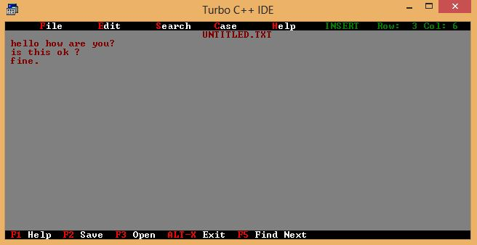

- CUT FUNCTION

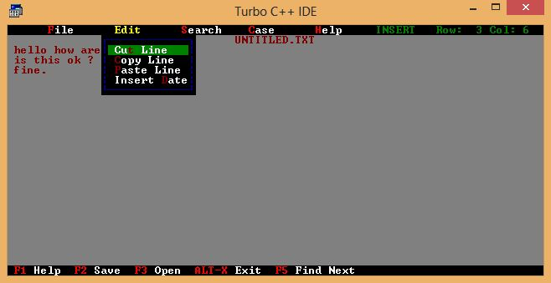

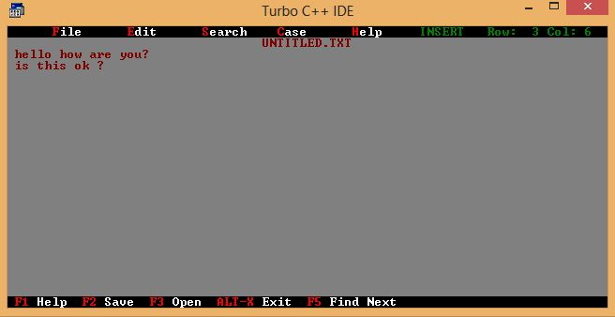

- Open function

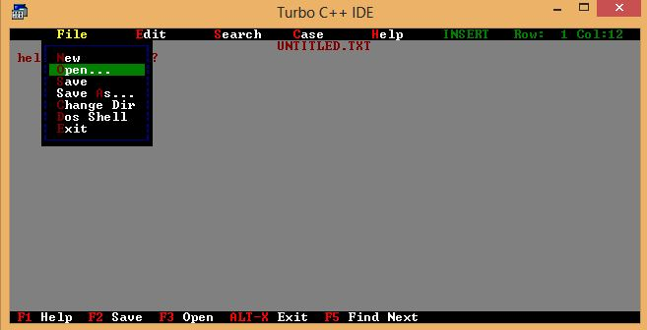

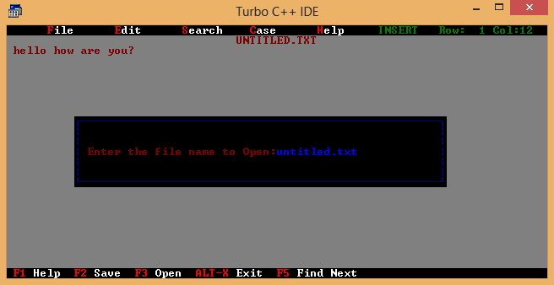

3.Save function

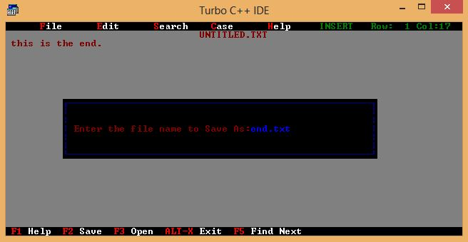

5.Paste function

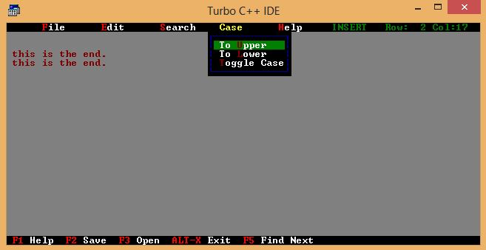

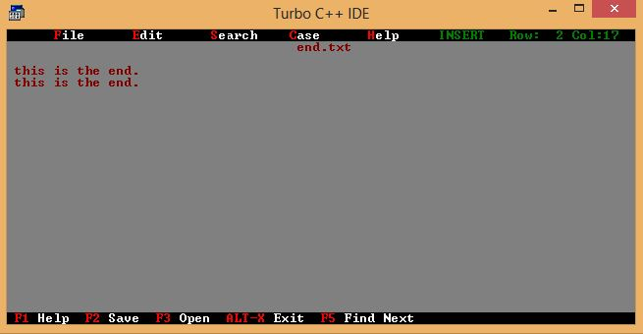

6.Converting to upper case

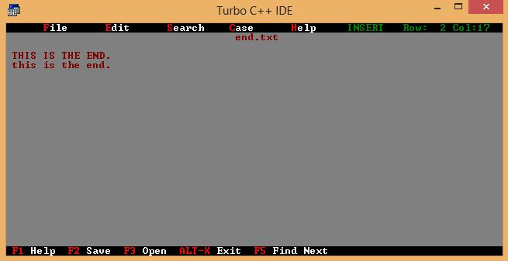

EXAMPLE

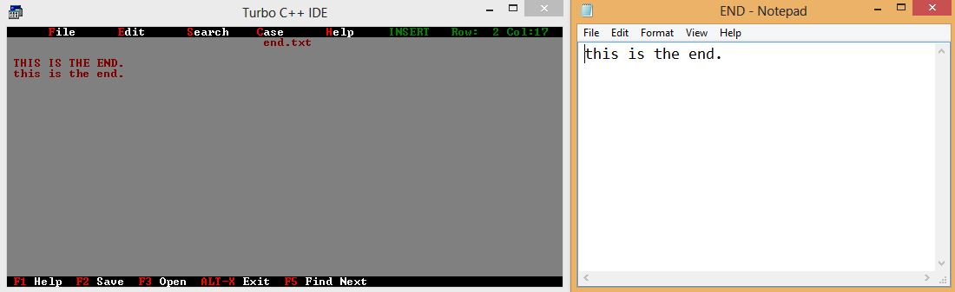

CONCLUSION

An overview of the functionality provided by TED is briefly mentioned below.
1. Users can open files stored on disk, located in any directory, provided that they know the name of the file. Users can also create new files using TED.
2. Once opened, files can be modified as desired, using the text editing features of TED. Text block operations, like Cut, Copy, and Paste can also be performed.
3. TED also allows users to search for information in the opened files. Additionally, a basic level of text formatting can be accomplished using TED.
4. Once any desired modifications are complete, users can save the modified file back to disk. The edited files can also be saved with a different location and/or name. TED also allows users to delete files on disk from within the editor.

REFERENCES

The following references were consulted during the preparation of this software

1. For documentation about the C++ Standard Template
Library Objected oriented programming with C++ BY Balaguruswamy
2.For programming reference regarding the C programming language
The C Programming Language – By Brian W. Kerninghan and Dennis M. Ritchie
3. System software by Leland L Beck 3rd edition

